1. The Board has tabled this study as the risk of putting an arterial catheter in a healthy person for an hour has not be adequately justified.

2. The risk to healthy participants could be mitigated by using this approach in patients who already have a catheter in place.

3. As well, as this study is utilizing a key resource in the ER, a letter from the site Chief is required.

This open source pulse oximeter is based on previous designs, but is indeed a new design. It will become a reference design for numerous implementations internationally that will be available in low and middle income countries. As such, calibration to the highest standard is essential. To justify the need for calibrating the device on human beings, I quote from ISO 80601-2-61: Particular requirements for basic safety and essential performance of pulse oximeter equipment. This is the document prepared by the International Standards Organization, a transnational body that sets standards for medical and other equipment. This standard is required by the FDA.

In this document, the expert committee states that “there is today no accepted method of verifying the correct calibration of a pulse oximeter monitor combination other than testing on human beings.” (p61; ISO 80601-2-61 document attached).

The committee further recognizes that:

“Pulse oximeter equipment is unlike other [medical] equipment, in that as of this writing, no simulators have been proven adequate for use as pulse oximeter equipment calibrators. The interaction of light and human tissue upon which pulse oximetry depends is complex. At least one effort is underway to produce a properly validated pulse oximeter calibrator that would model at least some of the optical intricacies, but no such effort has yet been completed successfully.
“Thus, the primary method of determining the SpO₂ accuracy of pulse oximeter equipment is to compare its readings with the readings of a co-oximeter (which determines by optical measurements in vitro the concentration of several forms of haemoglobin in arterial blood).” (p.62, Ibid.)
In discussing the accepted standard procedure, the ISO Committee says:

“The procedure to determine the calibration curve is called a controlled desaturation study. It typically involves providing healthy volunteer test subjects with breathing mixtures having reduced oxygen content. Arterial blood samples are drawn and measured with a co-oximeter, and the co-oximeter readings are plotted against R values observed during the interval when the blood is being drawn.”

An example desaturation-time profile from the document is included below, and demonstrates the need for multiple readings over time (Figure EE.1, Ibid). The document states “using single needle punctures as a source of arterial blood is likely to result in unstable SpO₂ values” (p59, Ibid), which suggests that the optimal method for acquiring data is through arterial cannulation.
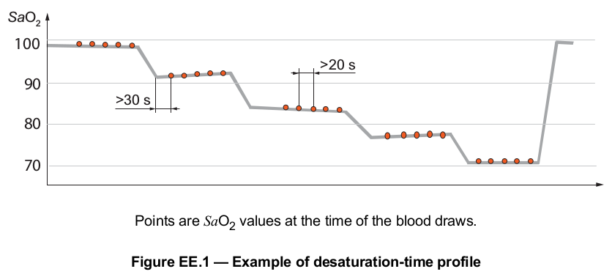
The use of a patient population with a catheter in place is discussed in the ISO document, which concludes that “in a clinical environment, measurements from pulse oximeter equipment and co-oximeters are often subject to non-optimal conditions and are difficult to match reliably due to circulatory instabilities or dynamics.” (p59, Ibid.) Furthermore, these patients would largely meet the exclusion criteria for a controlled desaturation study.

Peripheral arterial catheterization via the radial artery is safe. In one large systematic review that analyzed 19,617 cannulations, temporary occlusion of the artery was the most frequently found complication, with an incidence of 19.7% (Scheer et al, 2002; attached). The study authors go on to state that “generally, temporary occlusion of the artery has no serious sequelae. Permanent occlusion of the radial artery appears to be rare because it was reported in only four patients (mean incidence 0.09%).”

The study authors conclude that “on the basis of the present systematic review we can conclude that serious complications of the radial, femoral and axillary artery are rare, and that arterial cannulation is a relatively safe procedure.” (Ibid) Certainly, the possibilities for complication are why a trained physician will be administering the catheters and monitoring the patient.

3. As well, as this study is utilizing a key resource in the ER, a letter from the site Chief is required.

This has been discussed with Dr. Adam Dukelow, Chief of Emergency Medicine, and he is aware and supportive of this study. A letter from Dr. Dukelow is forthcoming.

Summary
In summary, all pulse oximeters must be calibrated against human subjects using arterial catheterization. This procedure takes some time (approximately 30-60 minutes) to ensure accurate data pairs. Healthy human volunteers should be used to avoid the variables introduced by using patients who tend to be hemodynamically unstable. Peripheral arterial cannulation of the radial artery is safe.

